**PROBLEM :** Using ALV, display Header details.  
•    When double clicked on document-number display item data corresponding to document number.  
•    Double clicked on payer number in header table. Go to transaction ‘xd03’and skip the first screen and display payer details.  
•    Double clicked on material number in item table. Go to transaction ‘mm03’and display material details.

* Program code

*&---------------------------------------------------------------------*  
*& Report ZALFY_WEEK3_TEST  
*&---------------------------------------------------------------------*  
*&  
*&---------------------------------------------------------------------*  
REPORT zalfy_week3_test.  
  
INITIALIZATION.  
  DATA : it_vbrk TYPE STANDARD TABLE OF zbilling,  
         wa_vbrk LIKE LINE OF it_vbrk,  
         it_vbrp TYPE STANDARD TABLE OF zitem,  
         wa_vbrp LIKE LINE OF it_vbrp.  
  
  DATA v_vbeln TYPE vbeln.  
  DATA : lt_fcat TYPE slis_t_fieldcat_alv,  
         lw_fcat LIKE LINE OF lt_fcat.  
  
START-OF-SELECTION.  
  SELECT-OPTIONS s_vbeln FOR v_vbeln.  
  PERFORM get_data.  
  
END-OF-SELECTION.  
  PERFORM display.  
  
FORM get_data .  
  
  SELECT * FROM zbilling INTO TABLE it_vbrk WHERE vbeln IN s_vbeln .  
  
ENDFORM.  
  
FORM display .  
  
  lw_fcat-col_pos = 1.  
  lw_fcat-fieldname = 'VBELN'.  
  lw_fcat-tabname = 'IT_VBRK'.  
  lw_fcat-seltext_m = 'Document Number'.  
  lw_fcat-outputlen = 20.  
  APPEND lw_fcat TO lt_fcat.  
  
  lw_fcat-col_pos = 2.  
  lw_fcat-fieldname = 'FKDAT'.  
  lw_fcat-tabname = 'IT_VBRK'.  
  lw_fcat-seltext_m = 'Billing Date'.  
  lw_fcat-outputlen = 15.  
  APPEND lw_fcat TO lt_fcat.  
  CLEAR lw_fcat.  
  
  lw_fcat-col_pos = 3.  
  lw_fcat-fieldname = 'KUNRG'.  
  lw_fcat-tabname = 'IT_VBRK'.  
  lw_fcat-seltext_m = 'Payer'.  
  lw_fcat-outputlen = 20.  
  APPEND lw_fcat TO lt_fcat.  
  
  lw_fcat-col_pos = 4.  
  lw_fcat-fieldname = 'NETWR'.  
  lw_fcat-tabname = 'IT_VBRK'.  
  lw_fcat-seltext_m = 'Net VAlue'.  
  lw_fcat-outputlen = 20.  
  APPEND lw_fcat TO lt_fcat.  
  
  
  
  CALL FUNCTION 'REUSE_ALV_GRID_DISPLAY'  
    EXPORTING  
      i_callback_program       = 'ZALFY_WEEK3_TEST'  
      i_callback_pf_status_set = 'PF_STATUS'  
      i_callback_user_command  = 'USER_COMMAND'  
      it_fieldcat              = lt_fcat  
    TABLES  
      t_outtab                 = it_vbrk  
    EXCEPTIONS  
      program_error            = 1  
      OTHERS                   = 2.  
  IF sy-subrc <> 0.  
* Implement suitable error handling here  
  ENDIF.  
  
ENDFORM.  
  
  
  
FORM user_command USING r_ucomm LIKE sy-ucomm  
  
                        rs_selfield TYPE slis_selfield.  
  
  CLEAR lt_fcat.  
  IF r_ucomm EQ '&IC1' AND rs_selfield-fieldname EQ 'VBELN'.  
    SELECT * FROM zitem INTO TABLE it_vbrp WHERE vbeln = rs_selfield-value.  
    lw_fcat-col_pos = 1.  
    lw_fcat-fieldname = 'POSNR'.  
    lw_fcat-tabname = 'IT_VBRP'.  
    lw_fcat-seltext_m = 'Billing item'.  
    lw_fcat-outputlen = 20.  
    APPEND lw_fcat TO lt_fcat.  
  
    lw_fcat-col_pos = 2.  
    lw_fcat-fieldname = 'MATNR'.  
    lw_fcat-tabname = 'IT_VBRP'.  
    lw_fcat-seltext_m = 'Material number'.  
    lw_fcat-outputlen = 15.  
    APPEND lw_fcat TO lt_fcat.  
    CLEAR lw_fcat.  
  
    lw_fcat-col_pos = 3.  
    lw_fcat-fieldname = 'FKLMG'.  
    lw_fcat-tabname = 'IT_VBRKP'.  
    lw_fcat-seltext_m = 'Quantity'.  
    lw_fcat-outputlen = 20.  
    APPEND lw_fcat TO lt_fcat.  
  
    lw_fcat-col_pos = 4.  
    lw_fcat-fieldname = 'VRKME'.  
    lw_fcat-tabname = 'IT_VBRP'.  
    lw_fcat-seltext_m = 'Unit'.  
    lw_fcat-outputlen = 10.  
    APPEND lw_fcat TO lt_fcat.  
    lw_fcat-col_pos = 4.  
    lw_fcat-fieldname = 'NETWR'.  
    lw_fcat-tabname = 'IT_VBRP'.  
    lw_fcat-seltext_m = 'Net VAlue'.  
    lw_fcat-outputlen = 20.  
    APPEND lw_fcat TO lt_fcat.  
  
    CALL FUNCTION 'REUSE_ALV_GRID_DISPLAY'  
      EXPORTING  
        i_callback_program       = 'ZALFY_WEEK3_TEST'  
        i_callback_pf_status_set = 'PF_STATUS'  
        i_callback_user_command  = 'USER_COMMAND'  
        it_fieldcat              = lt_fcat  
      TABLES  
        t_outtab                 = it_vbrp  
      EXCEPTIONS  
        program_error            = 1  
        OTHERS                   = 2.  
    IF sy-subrc <> 0.  
* Implement suitable error handling here  
    ENDIF.  
  
  ENDIF.  
  IF r_ucomm EQ '&IC1' AND rs_selfield-fieldname EQ 'MATNR'.  
    SET PARAMETER ID 'MAT' FIELD rs_selfield-value.  
    CALL TRANSACTION 'MM03'.  
  ENDIF.  
  IF r_ucomm EQ '&IC1' AND rs_selfield-fieldname EQ 'KUNRG'.  
    SET PARAMETER ID 'KUN' FIELD rs_selfield-value.  
    CALL TRANSACTION 'XD03' AND SKIP FIRST SCREEN.  
  ENDIF.  
  
  
  
ENDFORM.  
FORM pf_status USING rt_extab TYPE slis_t_extab .  
  
  SET PF-STATUS 'STANDARD_FULLSCREEN' EXCLUDING 'PDF'.  
  
ENDFORM.

* Header data

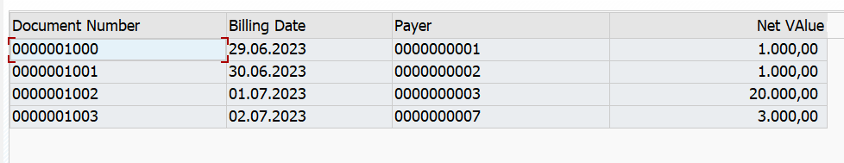

* Item data

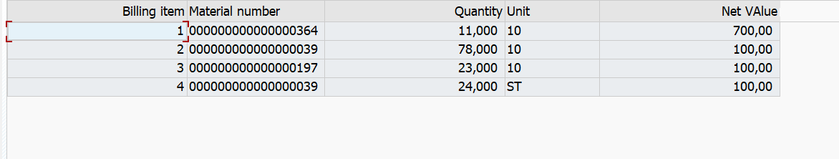

* Material input

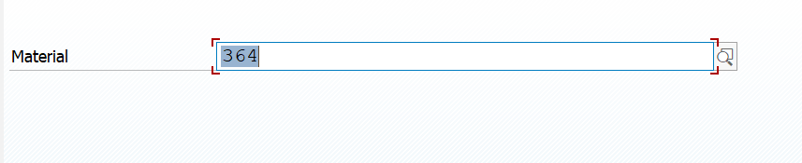

* Material details

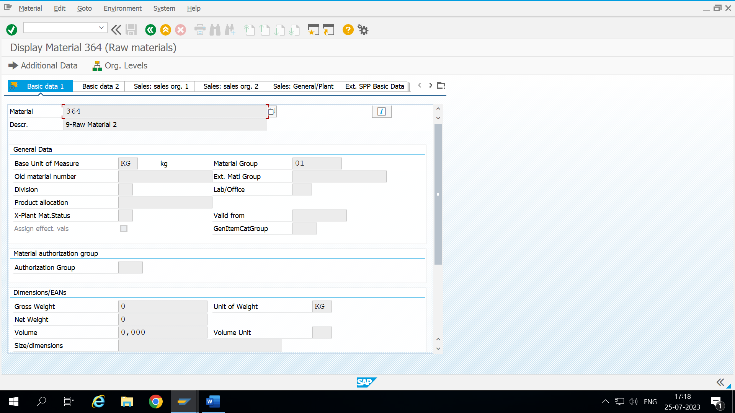

* Payer details

